

**Department of Mechanical Engineering**

**ME 222A Laboratory**

**Instructors: Prof. Kamal K. Kar, Prof. Bishakh Bhattacharya**

**EXPERIMENT 8**

**REFRACTIVE INDEX/ FILM THICKNESS**

**Group Number A2**

**Group members:**

* **Affan Ahmad 14042**
* **Akash Singh 14048**
* **Akhil Amod 14052**
* **Akshay Bagde 14059**
* **Akshay Bhola 14060**
* **Akshay Sharma 14062**
* **Albart Jose 14065**

**INDEX:**

|  |  |
| --- | --- |
| **TOPIC** | **PAGE NO.** |
| **Objective** | **3** |
| **Theory** | **3** |
| **Principle of operation** | **3** |
| **Experimental Setup** | **4** |
| **Importance of experiment** | **4** |
| **Procedure** | **4** |
| **Observations** | **5** |
| **Graphs** | **6** |
| **Results** | **10** |
| **Discussion** | **10** |
| **Conclusion** | **10** |
| **Precautions** | **10** |
| **References** | **10** |

**Objective:**

Determination of the thickness of a given sample using ellipsometry.

**Theory:**

Ellipsometry is a non-destructive, light optical analysis technique that requires neither sample preparation nor special measurement environment. Ellipsometry uses the fact that light undergoes some change in polarization when it is reflected off the surface of a material. The polarization change is characteristic of the surface structure of the sample.

**Principle of operation:**

Ellipsometry measures the change of [polarization](https://en.wikipedia.org/wiki/Polarization_(waves)) upon reflection or transmission and compares it to a model. This experiment is based on the property of light that linearly polarized light becomes elliptically polarized on oblique reflection from a surface.

The shape and orientation of the ellipse depends on the angle of incidence, the direction of polarization of incident light and properties of surface. This change in polarization of light is measured using a quarter wave plate followed by an analyzer. The orientation of the quarter-wave plate and the analyzer are varied until no light passes through the analyzer. From these orientations and direction of polarization of incident light, we can calculate the thickness of material using Fabry-Perot and Maxwell’s equations. Here the calculation of thickness is done using a computer software.

**Experimental setup:**

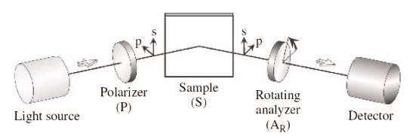

**Importance of the experiment:**

The measurement of thickness of materials spread as very thin layers is a difficult but important task. A whole lot of important properties of materials depend on the surface thickness. The refractive index of a material is also an important characteristic for the material to be used in various optical tasks. Hence knowing these properties correctly can help us in selecting the right kind of material for different applications.

**Procedure:**

1. Put analyzer, polarizer and quarter wave plate to null position.

2. Switch on the laser.

3. Rotate analyzer and remove the bright spot present, take down the initial reading of analyzer (This step is just for setting of quarter wave plate).

4. Now move the quarter wave plate and set for null condition.

5. Note down the angle of quarter wave plate and rotate it by adding 45 degree to initial reading for getting bright spot.

6. Move both arms up by 20 degree rotation.

7. Now put the sample (Hold the sample from marked side and put the unmarked side up).

8. Rotate analyzer and polarizer both simultaneously in 0 to 90 degree.

9. This gives the reading P1 and A1 for polarizer and analyzer respectively.

P2=P1+270 (if 0<P1<90)

P2=P1+90 (if 270<P1<360)

10. Set P2 and rotate the analyzer to get A2.

11. Provide the values of P1, A1 and P2, A2 on software available and calculate the thickness of the sample.

**Observations:**

**First observation**

|  |  |
| --- | --- |
| Quantity | Reading in degrees |
| P1 | 32.9 |
| A1 | 46.8 |
| P2 | 302.9 |
| A2 | 160.6 |

**Second observation**

|  |  |
| --- | --- |
| Quantity | Reading in degrees |
| P1 | 32.9 |
| A1 | 47.3 |
| P2 | 302.9 |
| A2 | 162.7 |

**Third Observation**

|  |  |
| --- | --- |
| Quantity | Reading in degrees |
| P1 | 33.4 |
| A1 | 46.9 |
| P2 | 303.4 |
| A2 | 158.1 |

**Graphs:**

Graphs will be plotted using the formula

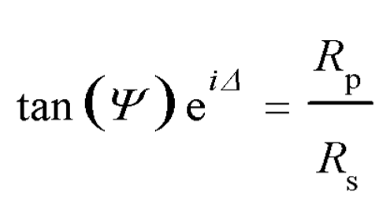

where

Δ=Phase shift angle, Relative Phase retardation

Ψ=Magnitude Ratio of Total Reflection Coefficients

Rp, Rs = Reflection Coefficients

Rp/Rs = Complex Reflectance ratio

For the First reading:

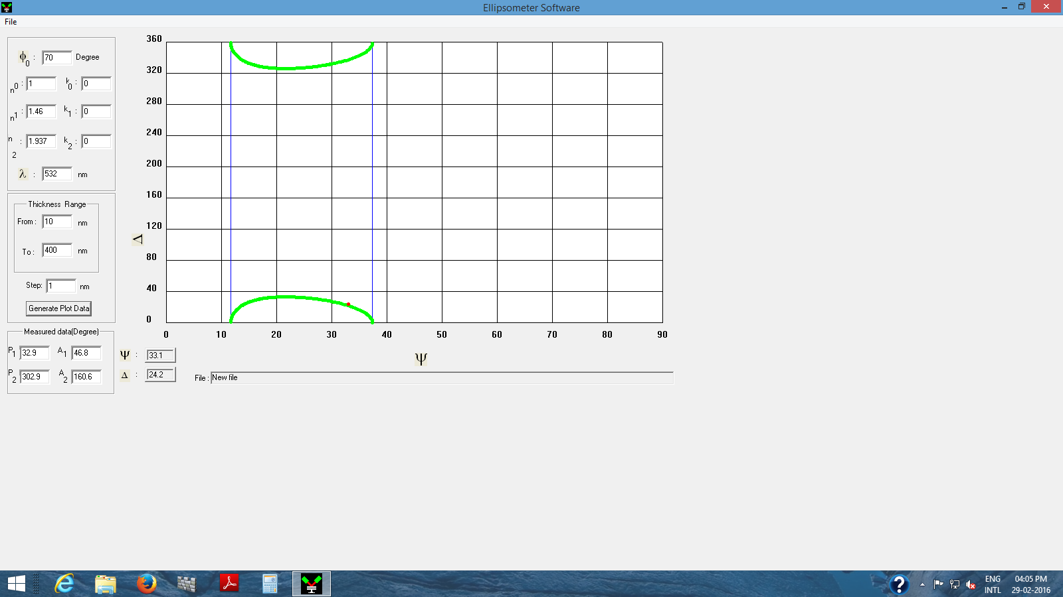

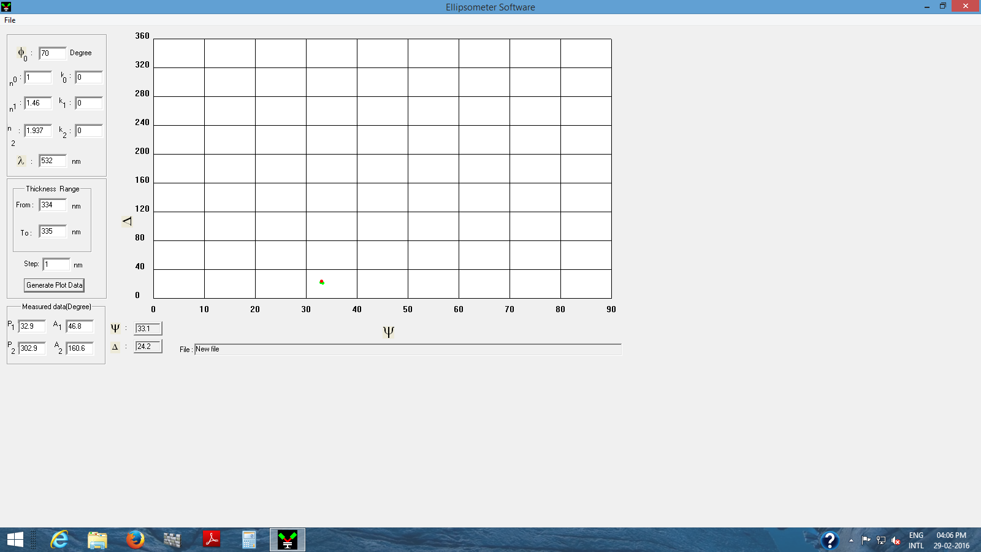

For the second reading:

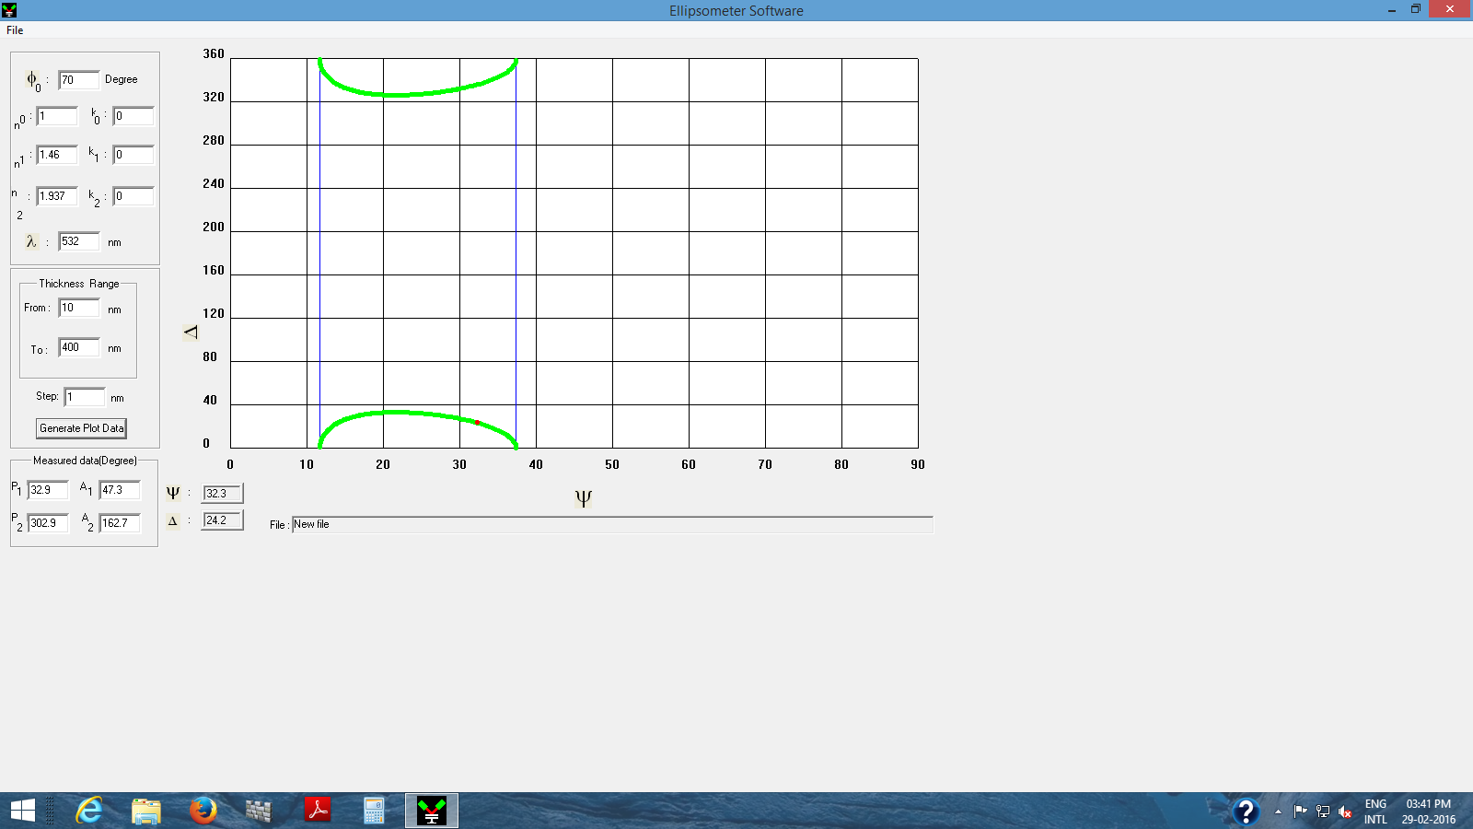

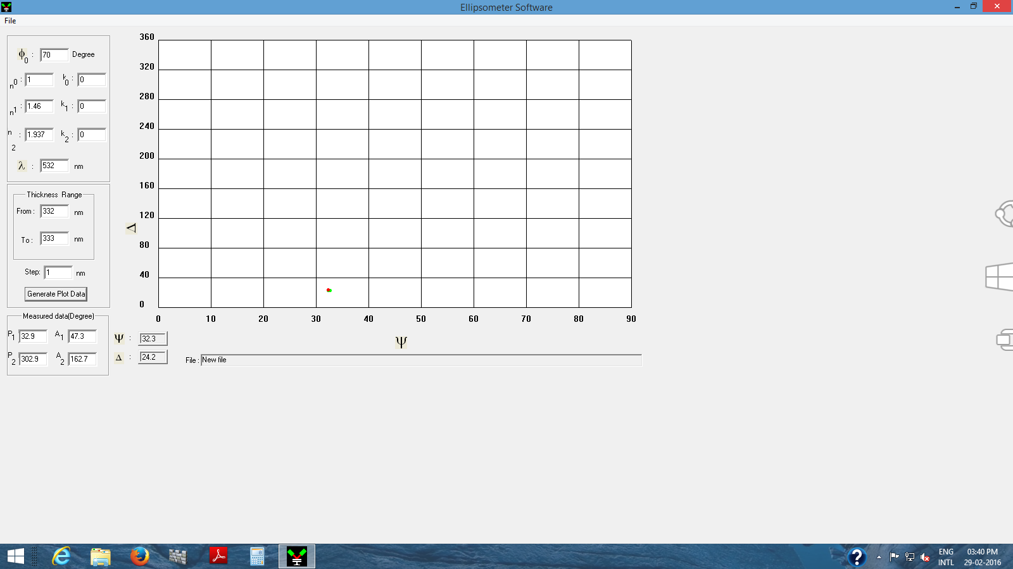

For the third reading:

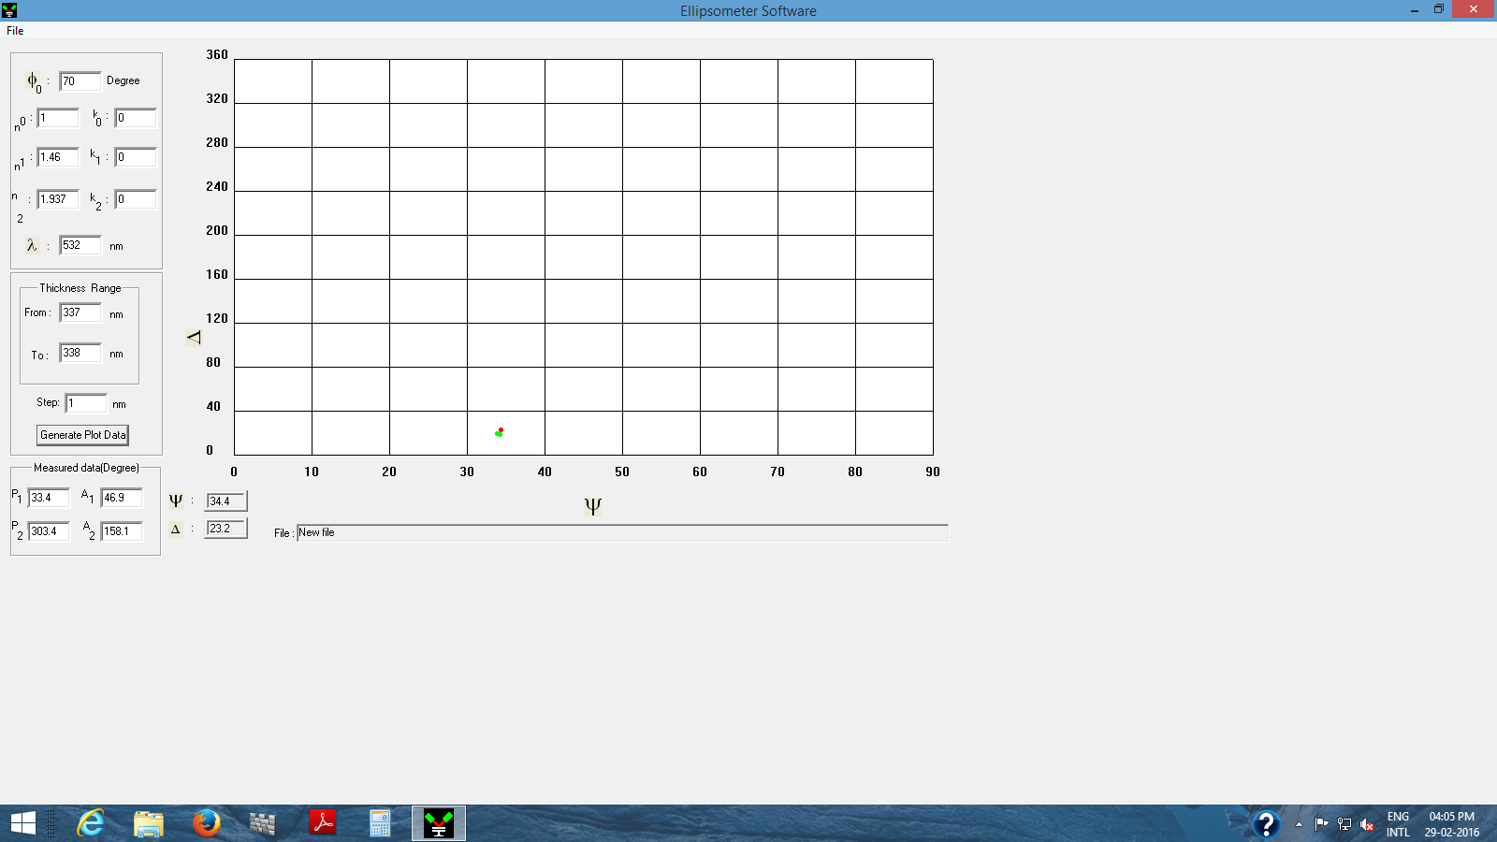

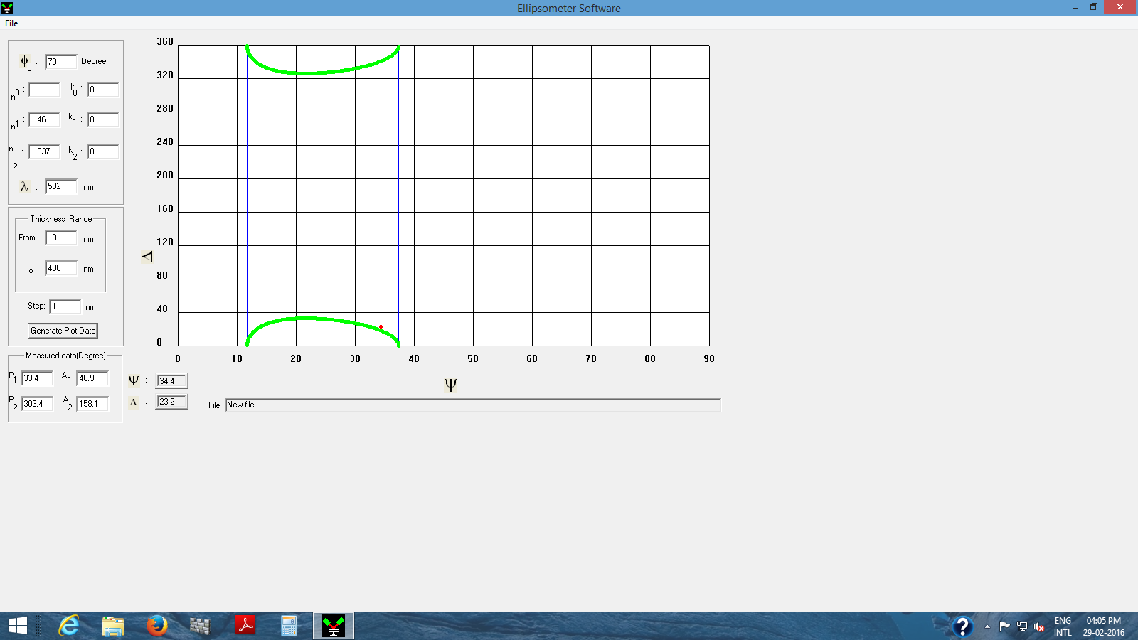

**Results:**

The average thickness of the given sample of SiO2 is between 332-335 nm.

**Discussion:**

The plots shown above are plotted using a software meant to measure thickness using ellipsometry. They give us the relation between phase shift angle and total reflection ratio coefficients. Using the software we estimate the thickness of the film by reducing the range of thickness till the green curve overlaps with the red dot indicating the thickness of the film.

**Conclusion:**

The conclusion of this experiment is that the average thickness of the film is between 332-335 nm.

**Precautions:**

* Don’t look into the laser beam and don’t wear reflective stuff like watches or rings.
* When working on the sample table, keep the laser lid shut.
* Don’t touch the film with your fingers.

**References:**

* William D. Callister, Jr., and David G. Rethwisch, Material Science and Engineering an Introduction, 8th Ed.
* Fundamentals of material science and engineering by William D. Callister, Jr. 4th edition.
* Wikipedia
* Lab Manual